**Superpro**

Laser Marker **XLM-04**

**Rev. 01 Introduction**

Document

**Info Content**

**Keywords** Laser Marker,Tape,Tray

**Abstract** This document describes the laser marker from XELTEK



**编辑日志**

|  |  |  |
| --- | --- | --- |
| 01 | 2020-11-26 | Initial Edit 01.1 |

**More information**

Welcome to visit our website: [**http://www.xeltek-cn.com**](http://www.nxp.com/)

Emails for more information : [**Sales02@xeltek.com**](mailto:sales.addresses@www.nxp.com)

**Contents**

1. System introduction 4

2. Equipment Characters 4

1. Do no harm to human because of the laser wavelength. 4

2. Long working life,small size. 4

3. Humanized operation process. 4

4. Stable beam quality because the output laser is not modulated. 4

5. Especially suitable for fine and precision marking. 4

6. High electron-optic conversion,50w power consumption 4

7. Air cooling,no maintenance,suitable for harsh environment. 4

8. Especially suitable for fine and precision marking. 4

3. Specification 5

# System introduction

The XLM-04 laser marker system consists of the laser generator, digital scanning system and the lens.

It’s special designed for the Super Bot series programming machines. After programming, the XLM laser marker will automatically engrave marks on the chips in tape or tray.

The focus of the lens for the tray and the tape are different.

Laser is outputted by EDFA and then go through the High-speed digital scanning

system. With stable output power, advanced optical mode, excellent beam quality, fast

marking speed, high efficiency, the XLM-04 works perfectly during the massive production.

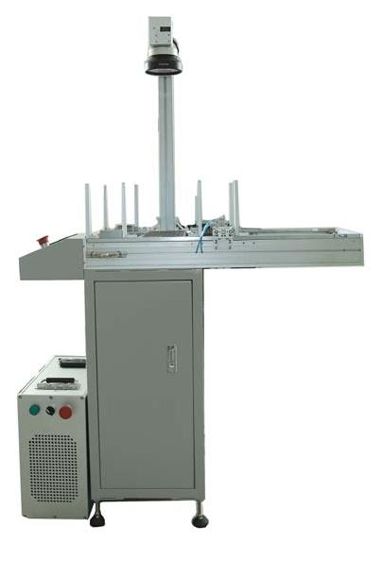 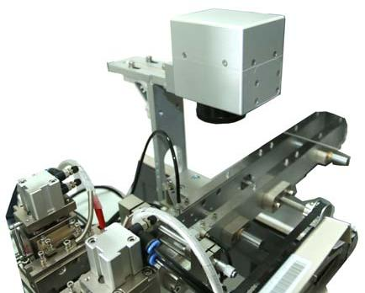

XML+Autotray XLM+Tapeout

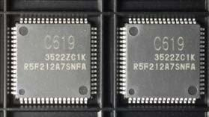

“C6919” mark sample

TIPS: Number,characters and symbols all can be used with XLM.

# Equipment Characters

## Do no harm to human because of the laser wavelength.

## Long working life, small size.

## Humanized operation process.

## Stable beam quality because the output laser is not modulated.

## Especially suitable for fine and precision marking.

## High electron-optic conversion,50w power consumption

## Air cooling, no maintenance, suitable for harsh environment.

## Especially suitable for fine and precision marking.

Laser output stability test:

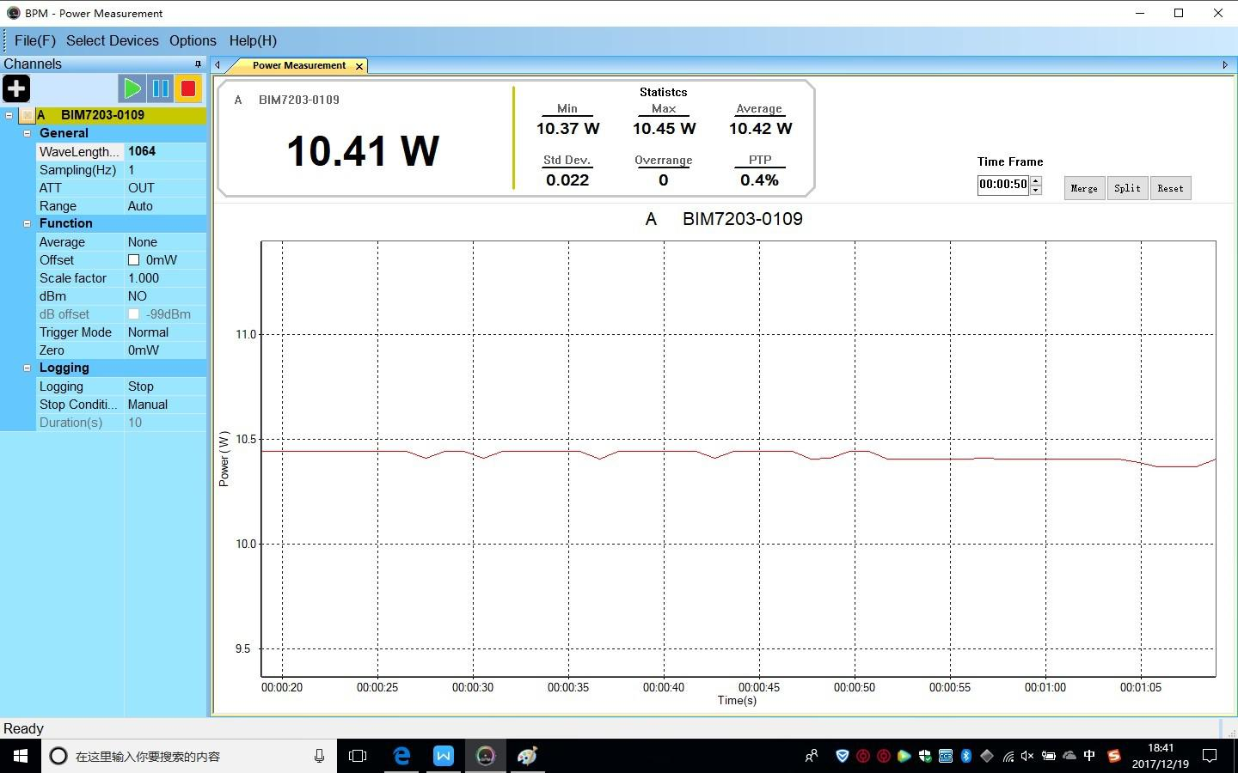

In the case of maximum power, the fluctuation

of output power is controlled at 0.5; the

adjustable range of laser power is 3-100.

Output laser has no modulation, no peak power, so it only

works on some non-metallic surfaces, laser single mode output,

excellent beam quality, laser wavelength 1.064um

# Specification

|  |  |  |
| --- | --- | --- |
| number | Technical indicators | Technical parameters |
| 1、 | The laser work material | Yb |
| 2、 | The laser wavelength | 1.064um |
| 3、 | Pump form | fiber |
| 4、 | The laser power output | 15W |
| 5、 | Power consumption | 300W |
| 6、 | Optical quality | Tem 00 mode |
| 7、 | Power supply | 220V/50Hz |
| 8、 | Stability of laser | ≤1% |
| 9、 | The galvanometer system | Digital scanning system |
| 10、 | Marking range | 70mmx70mm~300mmx300mm |
| 11、 | The resolution | ≤4um |
| 12、 | drift | Max 15um/℃ |
| 13、 | Scanning speed | ≥1200mm/s |
| 14、 | Cooling form | Air cooling |