SUPERPRO ® 7100
Advanced Gang Programmer
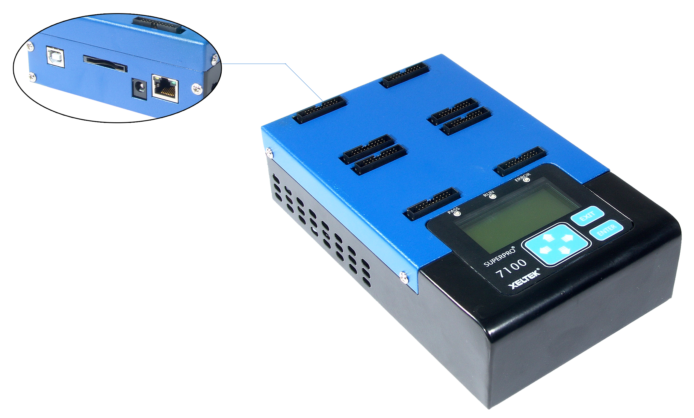

- Same programming design as SuperPro 7000
- Supports NAND FLASH, NOR FLASH, Serial EEPRO/FLASH and more
- Ultra-high programming speed.
- Programs four devices in parallel.
- PC hosted, network and stand-alone(no PC required)
- Manage up to 12 programmers in one GUI
- Industry grade quality and reliability.

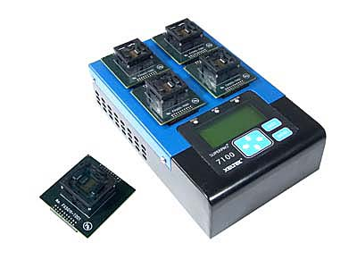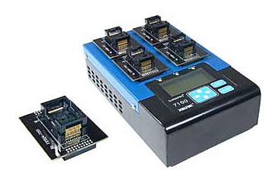
1 BGA137 Gang4 Socket 2 TSOP48 Gang4 Socket

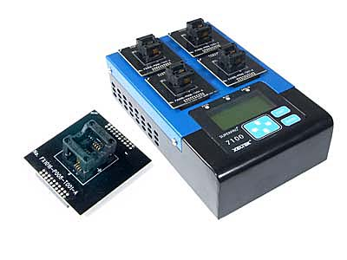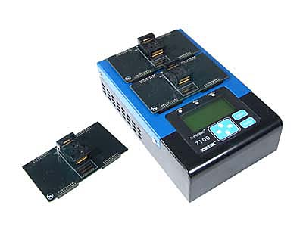
3 SOP8 Gang4 Socket 4 TSOP56 Gang2 Socket

Features  - Same programming engine with SuperPro 7000.  - Ultra-high programming peed. 10 times higher than SuperPro 5000 for eMMC.  - Industry grade quality and reliability. IC manufacturer approved programming algorithms.  - Supports NAND FLASH, NOR FLASH, Serial EEPROM/FLASH/NAND, and eMMC. Supports devices with Vcc as low as 1.2V.  - Support up to 4 chips in parallel.  - Many safety mechanisms are built including self-calibration, self-diagnosis, wrong chip placement detection, poor-pin-contacting detection, ID checking, over-current and over-voltage protection etc.  - Triple operation modes for various application requirements. 1）PC hosted mode. The programmer is controlled by PC via USB2.0; 2）Stand-alone mode. The programmer is controlled via a 6-Key keypad and a 20 character by 4 line LCD display. A SD card is used to store the project files. 3） Network mode. With the LAN port it’s an easy job to connect the programmer to LAN or Internet.  - Advanced and powerful software functions.  Production mode starts chip operation at the moment the chip is inserted in the socket properly.  - Project function simplifies processes such as device selection, file load, device configuration setting, program option, and batch file setting into one touch step. Barcode management automatically load project files to avoid manual mistakes.  Password can be set for project files and production volume control  Batch command combines device operations like program, verify, security into a single command at any sequence.  Dynamic buffer makes it possible that each chip is programmed with different data file. Applications including serial number, MAC address etc.  Log file and statistic table for quality tracking.  File Security by SD card and project file passwords, volume limit and network remote control.  Gang expansion Up to 12 programmers can be managed under one GUI as one concurrent production programmer.  - WINDOWS XP/Vista/Win7/ Win8 compatibility | Electrical and Mechanical Specification  - PC Interface： USB2.0(high speed)，LAN(100M)  - Stand-alone Storage Media：SD card  - Keypad and Display: 6 key keypad, 20Character x 4l Line LCD  - Power Supply: AC Adaptor Input AC 100V- 240V; Output: 12V/1.5A  - Main Unit Dimensions：184 x 160 x 78 mm  Weight: 0.8 Kg  - Package: Dimensions: 310 x 250 x 145 mm;  Weight: 1.65 Kg  - Temperature: ：0-40°C。  - Humidity： 20%-80%  Items Included  - SuperPro 7100 Programmer main unit  - AC adapter  - Software CD  - USB Cable  Optional Accessories  - Socket adaptors in various packages  - SD card for stand-alone operation  

