
User's Guide

XELTEK

Superpro®7500

Series

Ultra‐Fast, Stand‐Alone, 144pin

Programmer of the Future

XELTEK

1296 Kifer Rd. Unit 605
Sunnyvale, CA 94086
Tel: (408) 530‐8080 Fax: (408) 530‐0096
www.xeltek.com

IMPORTANT!
1. This manual applies to SuperPro/7500.
2. Make sure the software installation is completed before connecting the
programmer to PC.
3. Please read the manual carefully before using programmers.
4. Please use Xeltek Adapters. Non‐Xeltek adapters will cause error

XELTEK

1296 Kifer Rd. Unit 605
Sunnyvale, CA 94086
Tel: (408) 530‐8080 Fax: (408) 530‐0096
www.xeltek.com

SUPERPRO is the registered trademark of XELTEK.

Distribution and sales of this product are intended for use by the original purchaser under the
terms of the License Agreement.

This document may not, in whole or part, be copied, photocopied, reproduced, translated or
reduced to any electronic medium of machine‐readable form without prior consent in writing from XELTEK.

The information in this document is subject to change without notice.
Software Copyright 2012‐2020 XELTEK
Userʹs Guide Copyright 2012‐2020 XELTEK

Welcome

Welcome to the world of Xeltek SUPERPRO programmers. Xeltek has produced the

SUPERPRO line of IC programmers since 1985. Our motto is to provide high value
products at affordable prices. In the past 27 years, Xeltek has produced a string of
highly popular and successful programmers including SUPERPRO, SUPERPRO II,

SUPERPRO III, SUPERPRO V, SUPERPRO 680, SUPERPRO 8000, SUPERPRO 3000U, and SUPERPRO 9000 models.

SUPERPRO 3000U is the first model to incorporate both PC connected and stand‐
alone modes operations combined into one programmer. It is also the first programmer to break the barrier of 40,000 devices supported in the industry. SUPERPRO 3000U is by far the most popular IC programmer in the industry today.

Pushing the barrier further, Xeltek is proud to announce the family of SUPERPRO
7500 programmers. SUPERPRO 7500 retains all the good features of SUPERPRO

3000U, but, in addition, it is designed to program today's large size devices efficiently and effectively.

Feature Highlights

• The SUPERPRO includes ultra high speed programming via 32bit RISC MCU
device. This is especially suitable for programming high capacity NAND

Flash devices

• A 144 pin driver support is built-in to provide efficient programming of large
pin count devices, an additional pin expander module is not necessary to
program large pin-count devices.

• The SUPERPRO operates with a PC for engineering purpose or in stand-
alone mode, without a PC, for repeat production mode programming. This
provides seamless migration from engineering to production.

• The SUPERPRO communicates through a USB 2.0 port and operates on most

Pentium‐based, IBM compatible desktop/notebook computers.

• The SUPERPRO comes with a standard 48-pin DIP ZIF socket and supports
optional socket adapters to accommodate PLCC, TSOP, SOIC, SOP, QFP,

TSSOP and BGA package types.

• The programmer and software supports Windows XP, Windows Vista, and

Windows 7.

• For authorized users, the SUPERPRO can provide for automatic generation of

electronic serial numbers.

User Manual Organization

This manual includes the following major chapters,
• An introduction to the SUPERPRO series, including the system requirements
and the software and hardware installation

• Detailed explanations on the commands and the programming procedures

• Information about error messages and common problems

• An Appendix that includes the customer support information

Note: The software prevails in any discrepancy between it and the user manual, due
to any upgrades of the software. The information in this document may be subject to
change without notice.

Chapter 1 Overview of SUPERPRO® 7500

This section provides a brief introduction of SUPERPRO (1.1), software features (1.2),
structure of the handbook (1.3), system requirement for the installation (1.4), and
package content (1.5).

1.1 Introduction to SUPERPRO

The SUPERPRO is a menu-driven software that operates a series of cost-effective,
reliable, and high-speed universal programmers. SUPERPRO communicates
through a USB 2.0 port and operates with most IBM-compatible desktop and
notebook computers that based on Pentium. Menu-driven software interface makes
all the operations quite user-friendly.

1.2 Software feature

The USB 2.0 Series supports:

• Windows XP, Windows Vista, and Windows 7
• More than 43,000 types of devices, including E/EPROM, PLD, MCU, FLASH,
etc.
• Compatible with many types of file formats, such as Binary, Intel (linear &
segmented) Hex, Motorola S, Tektronix (linear & segmented), Jed, pof, etc.
• It supports a plug-in test (48 pins or less) to detect defective chips, improper
insertion and pins that are poorly contacted.
• SUPERPRO has an integral full-screen buffer editorial environment with
commands such as fill, copy, move, swap, etc.
• Electronic serial numbers are generated automatically.
1.3 Structure of this User's Guide

The content of this User's Guide is structured into three major sections,

Chapter 1 is an overview and introduction of the SUPERPRO, describing the
system requirement, installation of the hardware and software.

Chapter 2 - Chapter 5 are detailed specification and explanation of all the
features, commands, and function modules.

In Appendices, there are supportive information and guide for trouble-shooting

1.4 System requirements

The minimum system configuration requires:

• A desktop or laptop computer with Intel Pentium or an equivalent processor
• Windows XP, Windows Vista, and/or Windows 7 operating system
• 1 GB free space on the hard drive
• Standard (USB 2.0) compliant socket
• A CD drive

1.5 Package content

A standard SUPERPRO programmer package includes:

- A Programming host module
- A DIP48 socket (SUPERPRO/7500 is accompanied with DIP48 EX0001)
- A Power supply unit
- A USB 2.0 connection cable
- A CD contains driver software
- A user's registration form

Chapter 2 System Installation

This chapter provides a brief guidance on how to install the SUPERPRO software
and connect the programmer hardware properly.

NOTE: To avoid complications during the installation process, you must setup the
software before connecting the programming hardware (the USB device) to your
computer. That is, installation through the "Add New Hardware Wizard" of

Windows system is NOT recommended (this might lead to wrong drivers with a
different compatible device ID).

2.1 Software Setup

Select the software to setup your SUPERPRO programmer either from the CD‐

ROM or by downloading the program from the Xeltek website. Instructions for both
methods are described below.

2.1.1 Software setup from CD

1. Insert the CD into the CD-ROM drive.
2. If the setup program does not start automatically, run SETUP.EXE located in
the root directory.
3. Select the appropriate programmer model.
4. Click Setup.

NOTE: Each model has its own software and they are NOT compatible.

2.1.2 Download the software from website and setup (recommended)

You can also download the specific software for a certain model at Xeltek
website: http://www.xeltek.com. Select the icon to download the appropriate file for
your programmer. Once you have saved the file to your computer, run it to setup
the software. The following procedure describes the setup process step by step.

1. Once the setup program is running, a dialog box displays to allow the user
choosing a preferred language. Select one from the drop down list and click
OK to continue

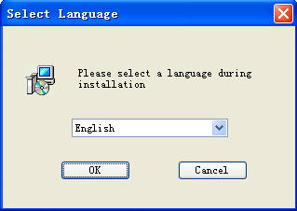

2. An installation wizard will be displayed (as illustrated below). Click Next to
continue.
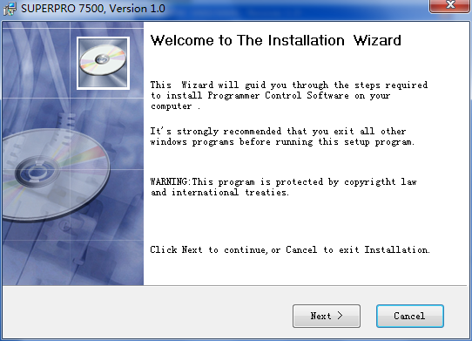
3. A License Agreement will be displayed. Click I Agree to continue.
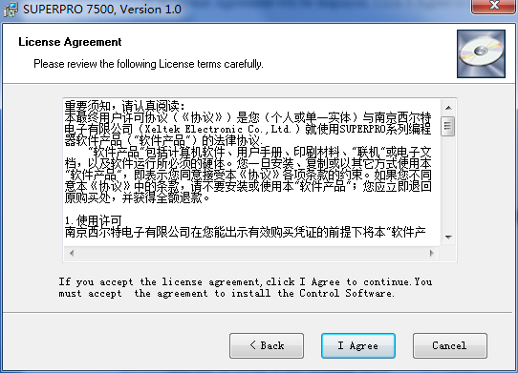
4. Choose the Destination Location in which the driver software will be
installed. Once the destination file folder is selected, click Next to proceed.
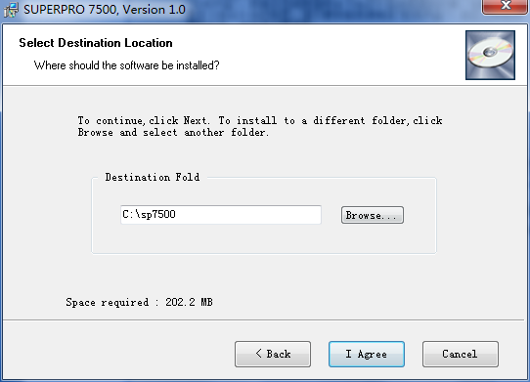
5. Another dialog box will be presented and allow the user to choose whether
creating a start menu icon and/or a desktop icon. Once correctly check the
tick box(es), click Next to continue.
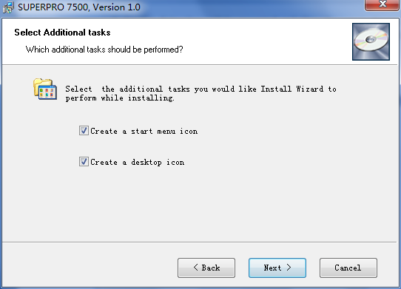
6. Check the previous selections and click Install to start the installation
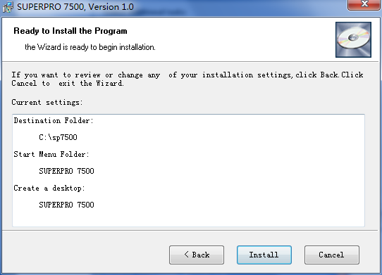

NOTE: If you are using the Windows Vista system, the operation system may

display the following dialog box to ask you whether to install the software. Select

Install this driver software anyway.
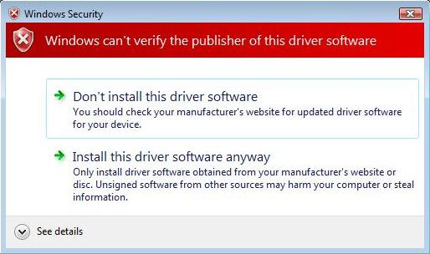
7. Once the installation is completed, click Finish.
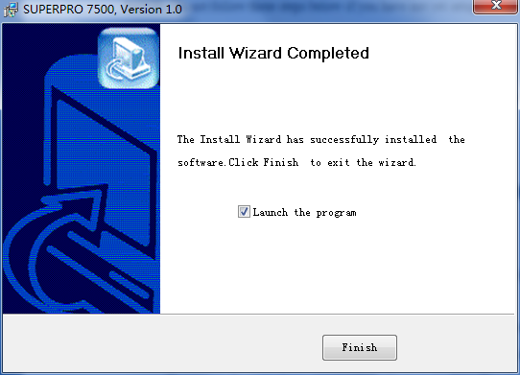
2.2 Hardware and Driver Installation

After you set up the software, you can install the hardware and driver. The

following procedure explains the installation process.

NOTE: Do not follow these steps below if you have not yet setup the software (see

section 2.1).

1. Make sure all other programs are closed during the installation process.

2. Connect the programmer module to the computer through the USB port.

3. Turn on the power switch of the programmer module.

When you connect the new hardware, the system initiates the New Hardware

Wizard, which locates the driver from the software you have just installed.

The system displays alerts one at a time, illustrated below. The alerts on your

system may be slightly different.
4. After you open the application software for the programmer, the system

automatically starts the initialization. If it does not, make sure the

programmer is securely connected to the computer and that the power switch

is on.

Chapter 3 Quick Guidance of the Software Features

This chapter is a quick guidance of the SUPERPRO® software. It describes the

functions and features of the programmer that are most frequently used. The

SUPERPRO 7500 provides two programmers in one, they are: PC mode for engineering

and Stand-alone mode for production.

• Under PC hosted mode, a PC controls the programmer via a high-speed USB

connection to program a chip.

• Under stand-alone mode, the user controls the programmer via 20-characters,

4-line LCD display with 6-KEY keypad.

In this chapter, all the features being described are in PC mode, while the stand-

alone mode is described elsewhere.

3.1 The User's Interface (main screen)

The main SUPERPRO screen is illustrated below. Each part of the user interface is

labeled with a number and described below.
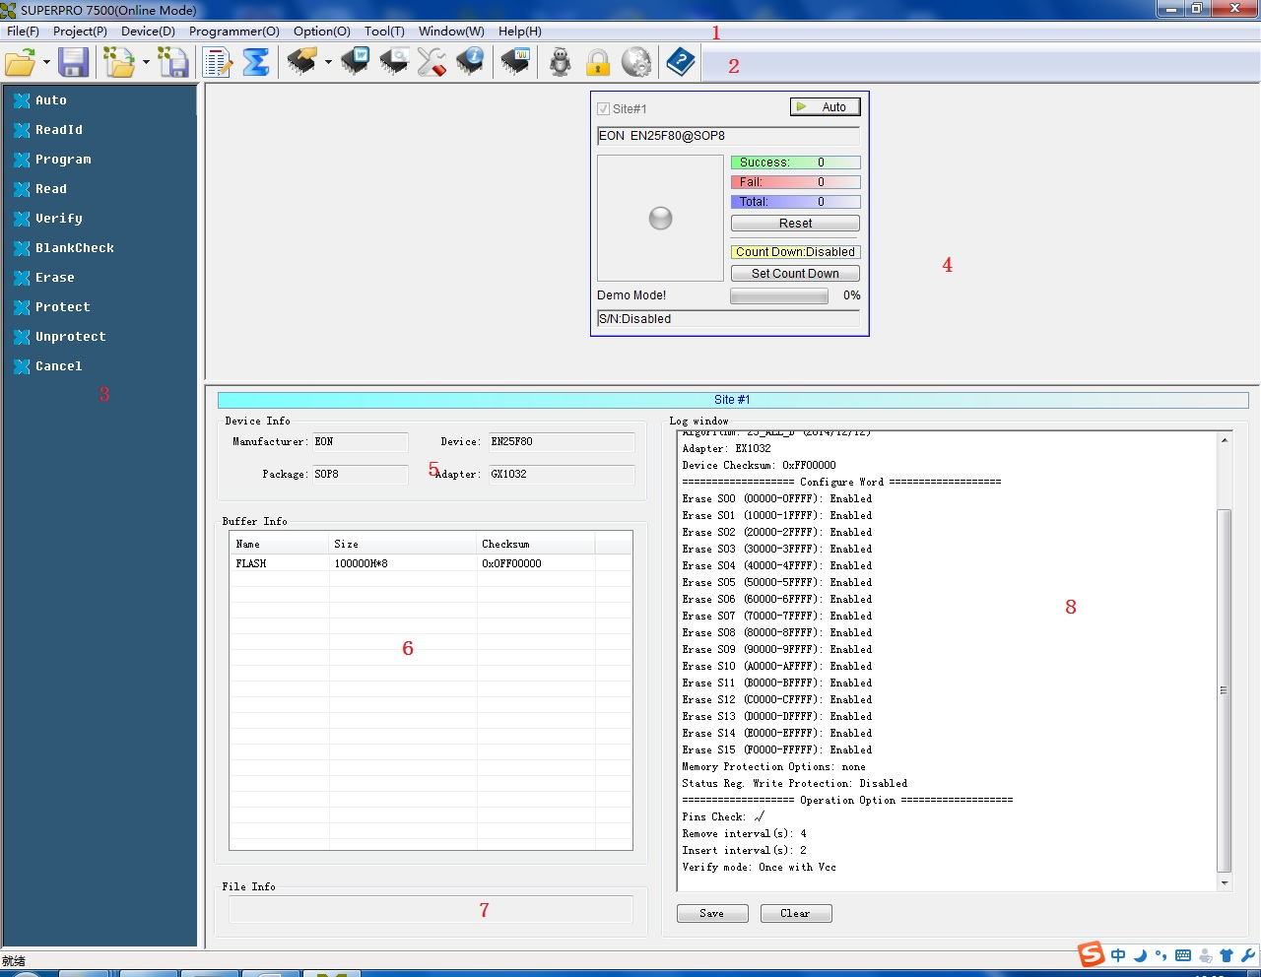
1. The Menu Bar provides access to the File, Buffer, Device, Option, Project,
and Help menus.

2. The Tool Bar offers quick access to many commonly used functions.

3. The Command Window enables shortcut to many commands and operations.

4. The Programmer Statue Panel shows the state of the current project and
programmer.

5. The Device Panel shows the connected device.

6. The Buffer Panel shows the state of the buffer.

7. The File Panel shows some basic information of the loaded file.

8. The Log Window displays the operation history.

A detailed specification of the Programmer Statue Panel is shown in the picture below

and described accordingly to the numbered notation.

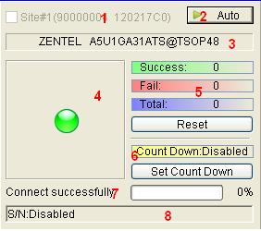

1. Module number and the ID of the programmer

2. Auto/Cancel button

3. Device name and the manufacturer information

4. Statue bar shows the success/failure of the programmer

5. Statistic information panel

6. Count down settings and information

7. Connectivity and progression of the programmer/project

8. Serial number

3.2 Programming Procedures

This section provides information on steps for common procedures to programme

devices using SUPERPRO 7500.

Before using the programmer to program a device, make sure that the programmer

is installed properly and that the computer and programmer are communicating

successfully. Make sure that you have the appropriate adapter for your SMD devices,

if applicable. Insert the chip correctly. Follow the guidelines of the standard chip

insertion markings near the pin-driver socket. However, if you select SMD or a

device that requires non-standard insertion, the system prompts you with the

appropriate chip insertion.

3.2.1 Select the device

To open the Device Selection window, choose one of the following options:

• Select the Device Selection icon

• Select the Device menu and select the Select Device (Device) option.

The system then displays the Device Selection screen as shown below.
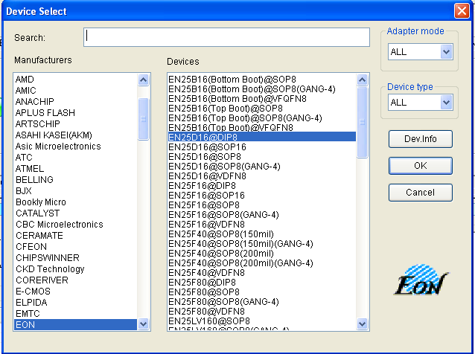
NOTE: The red device name means that such device(s) need authorization to use.
3.2.2 Load data into buffer

One can load data into the buffer by reading data either from a file or a master chip.
- To read data from a file, select Load File from the File menu. The system
displays the Load File dialog box. To make sure the loaded data is correct one
can review the information in the Buffer window.
NOTE: Some Hex or S record files contain non-zero file initial address. In this
case, enter the start address in the File Address box.
- To read the data from a master chip, complete the following steps:

- Insert the master chip in the socket.

- Select Read on the Device Operation window in the main screen. The

data will be copied from the master chip to the buffer memory.

- To make sure the loaded data is correct one can review the

information in the Buffer window.

- If desired, you can save the data to a disk for later use.

NOTE: The read function is not available for some devices, including those

have been encrypted.

3.2.3 Set options

- Click Operation Option from the Option menu to open the Operation Option

screen. Set each of the following options:

- Insertion Test indicates whether to check the pin contact.

- Device ID Check indicates whether to check the ID of the device.

- Beeper indicates whether the beeper alarms a sound when the

operation succeeds/fails.

- Auto Increment Function indicates an automatic increase in the label

number written to each chip.
- Address Change indicates whether a different start and end address

shall be applied for the programming zone of the device.

- To set the order of the batch processing functions, select Edit Auto from the

Options menu. The system displays the Edit Auto screen.

- For devices that include the configuration word, you must set the

configuration word before programming to ensure that the chip can be used

on the target system. The configuration words for some devices are contained

in the data file. Therefore, the system automatically loads the configuration

word into the configuration word buffer when loading the data file. For some

devices, you must manually make the selection. Select Device Configuration

Word from the Device menu to open the ConfigWord screen.

- Many devices must meet some special requirements for the programming of

a chip, including special algorithms conventions. Read the device manual or

instructions carefully and adjust the operation steps or buffer data as needed.

If an adapter is required for programming, the system displays information

about the adapter in the device information screen.

3.2.4 Execute programming

Insert the chip properly into the socket. If the prompt information indicates a need

for an adaptor, you may purchase the adapter. The operation procedure for the

programming of a chip is described as the following steps:

- Blank Check

NOTE: You can skip this step if the chip is brand new.

The Blank Check fails on electrically erasable chips containing some

information. In this case, perform the Erase operation first. You do not

need to erase EPROM chips for which the data can be overwritten.

- Program

- Verify

NOTE: This step is necessary. The chip must pass Verification before the

programming can be implemented. Some chips provide only the

accumulation check function, such as VerifyCRC instead of a unit-to-unit check function. Very few chips do not provide the accumulation check function.

- Security or Protect if encryption is required

NOTE: You may need to set the configuration word before performing

encryption. Refer to Device Configuration Word on page 37 for more

information. Select Auto to finish all the operations in one step.

- Execute Production Mode to Program Chips in Batches

Select Production Mode from the Option menu to program devices in large
quantities. This function facilitates the job of the user who programs chips in batches. In order to program chips in batches, the programmer always conducts the insertion test. The programmer waits for the chip insertion to initiate while the system displays the following prompt: Please, insert a device into the socket. Once you have properly inserted the chip, the auto batch-processing command starts automatically.

3.3 Programming When Connected by Hub

SUPERPRO® 7500 provides a connection hub and user can simultaneously operate

multiple SUPERPRO® 7500 programmer by using the hub.

Click menu Programmer -> Module Management, and select the number of the

programmer you want to operate. Picture below shows the interface when

simultaneously operating three programmers.

Every programmer has a unique number. The programmer's first line of the LCD

display will show the number of this programmer. The module that is selected at the

time will be highlighted. The device that is going to be programmed can be different

type(s) in each of the module that is connected through the hub.

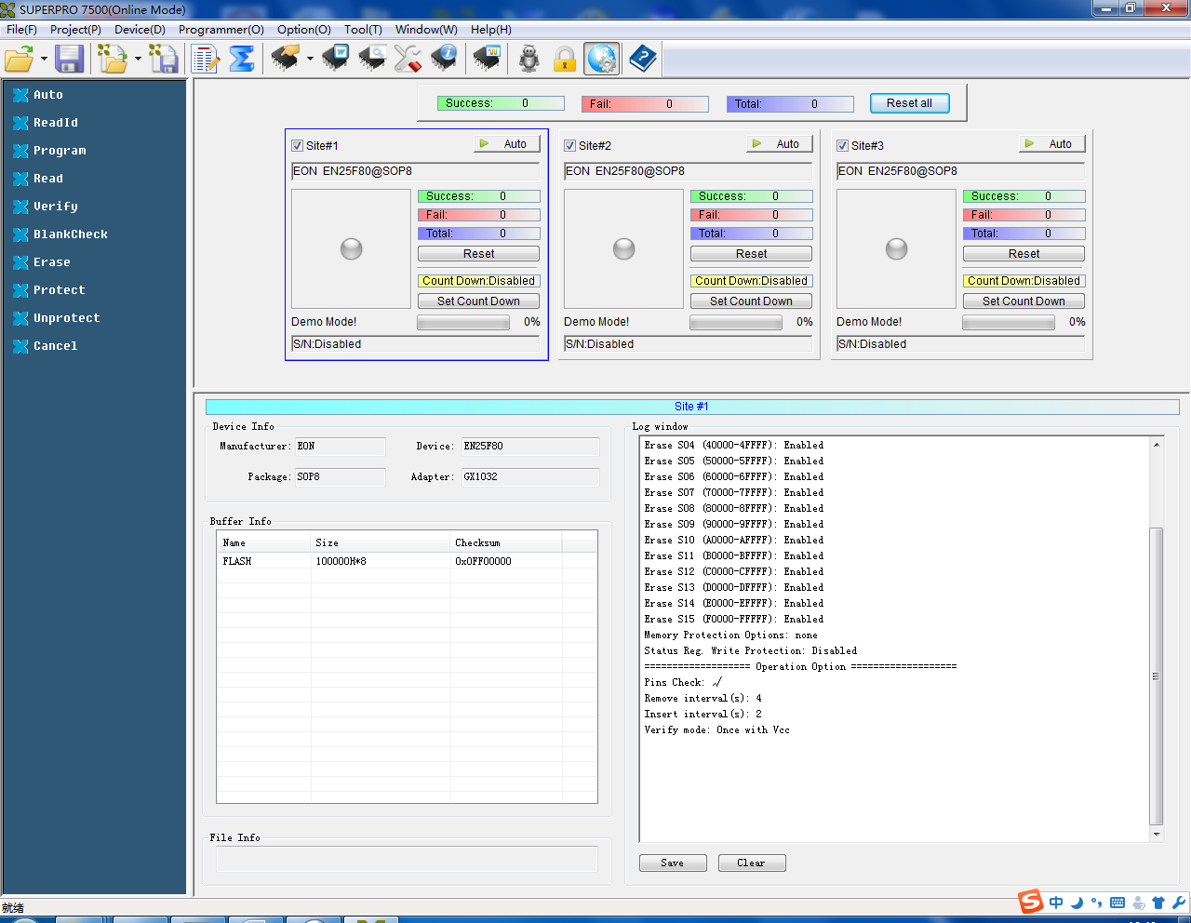

- In normal mode, all operations (i.e. selecting devices, loading documents and

programming) are carried out in the programmer that is selected and

highlighted at the time being.
- In global configuration mode, all the operations are carried out in the

programmer(s) that is selected with the check in tick-box(es).

NOTE: Choose specified hub for XELTEK to connect SUPERPRO/7500, and

currently up to 8 programmer can be operated simultaneously.
`
Chapter 4 Functions and Commands

This chapter provides a detailed specification and explanation of the SUPERPRO®

software. It includes the description of the functions and commands that is listed as

below,

• File Menu and Tool Bar (4.1)

• Project Menu (4.2)

• Device Menu (4.3)

• Option Menu (4.4)

• Tool Bar (4.5)

• Log History Window (4.6)
4.1 File Menu and Tool Bar

The File menu provides access to the commands of Load, Save, Recent Projects, and

Exit. Each function is described in the following sections.

4.1.1 Load File

There may be one or more data buffers in the device. If several data buffers are

displayed after you have selected the device, refer to the name and the data manual

for the meanings of the buffers. The two data types of the device are Data

(HEX/ASCII) and Fuse.

• For most EPROM and SCM, the data type is Data (HEX/ASCII).

• The data type for PLD device is Fuse.

After you select the device, the software automatically will identify the data buffer

type. You can review the buffer data types if you open the Edit dialog box for the

data buffer. When some file data are loaded into the data buffer, the following rules

apply:

• With a HEX/ASCII data buffer (EPROM, MCU etc.), the system assumes that

8 bits of the data are valid.

• With a JEDEC buffer (PLD/PAL), the system considers the lowest bit (1 bit) of

the file data valid.

Select Load from the File menu to open the Load File dialog box, as illustrated

below. The red labels refer to the numbered notations follow this figure.

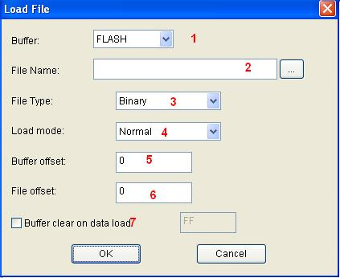
1. Buffer. To select the Buffer name from the drop down list. The system loads

the file data into the buffer accordingly.

2. File Name. To enter the name of the data file to load it, or you can select

Browse and choose the file using the Select File box .
3. File Type. To select the type of the file from a drop down list. Different file

types are included here, e.g. Binary, Intel Hex, Motorola S record, JEDEC,

POF, TI, etc.

4. File Mode. To select one of the following File Modes from the drop down list:

• Normal to load the whole file

• Even to load the first byte and discard the second byte out of every

two bytes

• Odd to discard the first byte and load the second byte out of every

two bytes

• 1st byte of 4 to load first byte and discard the other three bytes out of

every four bytes

• 2nd byte of 4 to load the second byte and discard the other three bytes

out of every four bytes

• 3rd byte of 4 to load the third byte and discard the other three bytes

out of every four bytes

• 4th byte of 4 to load the fourth byte and discard the other three bytes

out of every four bytes

• 1st 2_byte of 4 to load the first two bytes and discard the other two

bytes out of every four bytes

• 2nd 2_byte of 4 to load the last two bytes and discard the other two

bytes out of every four bytes

5. Buffer Address. To indicate a different initial address of the data being

loaded into the buffer.

6. File Address. In case the file type has a non-zero start address, enter the data

offset address in the File Address field. Make sure to enter the correct

address, because an incorrect file offset address causes part of the buffer to be

filled with FF (or incorrect data).
7. Buffer clear on data load. Tick this checkbox will enable the user to fill the

data buffers with the specified data.

NOTE: Ticking the checkbox of Custom File will disable most loading option.

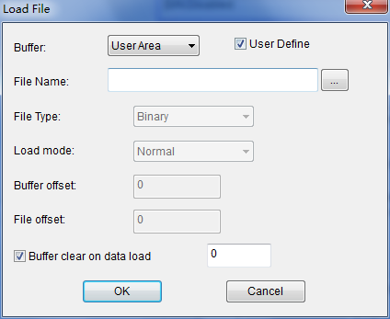
4.1.2 Save File

Select Save from the File menu to save data in the current buffer to a disk file. A

dialog box titled as Save File will be displayed and the saving options are similar to

those in section 4.1.1 Load File.

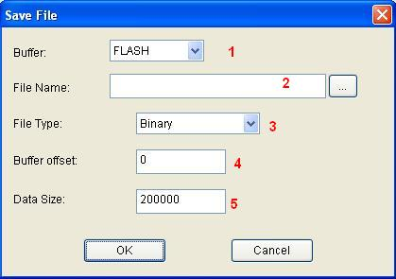
1. Buffer.

2. File Name

3. File Type

4. Buffer Address

5. Data Size. To enter the save data size in number of bytes.
SUPERPRO® 7500 User's Guide

3. File Type

4. Buffer Address

5. Data Size. To enter the save data size in number of bytes.

4.2 Project Menu
The project file contains all of the information and preparations before programming.

It can also be used to restore the working environment that has been saved

previously. The project file includes:

• The current device's information, such as:

o Manufacturer

o Device type

o Pin size

o Data file name

o Current buffer data

NOTE: The buffer data may differ from the data file due to revisions.

• All Operation Option settings

• The content of the Auto mode

• Software module related to the project

NOTE: The project content is related to the programmer software. If the software

has upgraded or has been re-installed to another folder, the saved project files

become ineffective
4.2.1 Load Project

Select Load Project from the Project menu to load a project file. Select the file in the

File dialog box. Following the information that is provided by the project file, user

can change the device(s), data in buffer, and operation option accordingly.

If the project contains “dynamic password”, a random serial number will be displayed. User should offer the serial number to the project maker. The project maker generates password by the tool “Password Generator” (please refer to ““Password Generator” for details). Then User input the password and load the project.
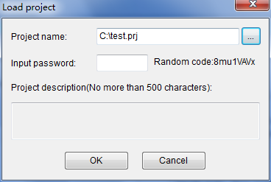

4.2.2 Save Project Files

Select Save Project Files from the Project menu to save the current working
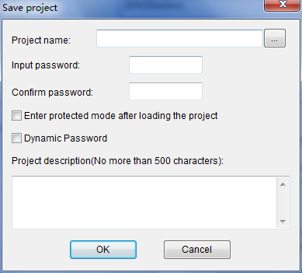
environment to a specified project file. To ensure the security of the data, you can

encrypt the project file.

When the option “Enter protected mode after loading the project” is selected, Dialog “Protected mode Setting” pops up. Please refer to “Protected mode” for details.

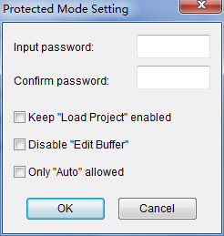
Dynamic Password: Please refer to “Load project” and “Password Generator” for details.

4.2.3 Manage Project Library

The stand-alone operation is when the programmer hardware is not connected to a

computer, and uses information saved in its own module for volume production.

The stand-alone file includes all the information needed for programming the device.

This enable the user to prepare the project file(s) before starting the programmer's

operation.

The project file being saved in the stand-alone mode will be manageable using

Manage Project Library function. This type of file can be stored in the SD card

incorporated in the SUPERPRO® 7500 programmer.

NOTE: 1) Besides using Manage Project Library function, user can also copy the

project file(s) by SD card replication;
2) SD card's file system must be FAT32.

The figure below shows a typical Manage Project Library window
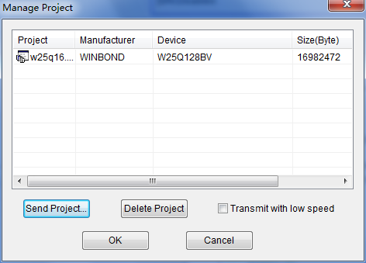

Some basic commands related to the project file operation are:

• Send Project. This will send the existing project file(s) to the SD card. One

can also encrypt the SD card to protect the data.

• Delete Project. To delete the project being selected.

There are many SD card manufacturers in the market and the quality varies a lot

across different brands. The ones from KingstonTM, and SandiskTM is recommended.

The default operation speed is high transfer rate, where low transfer rate (tick the

check-box) is preferable when the sending project operation fails. If there are many

large project files need to be sent, then replication of SD card is recommended.

4.2.4 SD card encryption

SUPERPRO® 7500 enables the encryption of SD card. Some SD card encryption

operations are,

• Set password. To set a 6-character password for a SD card. Once a SD card is

protected by a password, it becomes encrypted and needs the password for

any operation.
• Unlock. To enter the correct password enable operation on the SD card when

it is connected on-line. However, if the SD card is off-line/disconnected, the

user has to unlock it again for any other operation.

• Erase Password. This operation actually wipes all the information that is

stored in the SD card and removes the password. After this, the SD card

needs to be format using FAT32 file system, so as to be compatible to

SUPERPRO® 7500. One does not have to unlock the SD card to carry out the

Erase Password operation.

4.3 Device Menu

4.3.1 Device selection

Refer to section 3.2.1 for the operation of device selection.

4.3.2 Device information

Click Device→ information will display the device information in a window (see

the figure below).

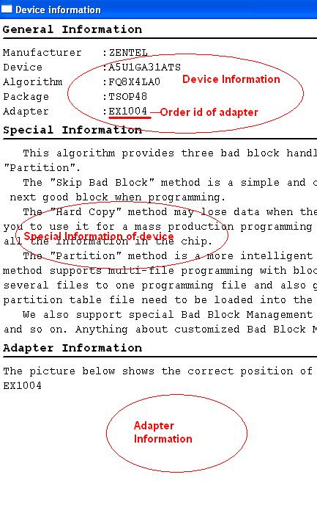

4.3.3 Manage data in buffer

There are two major types of buffer, Fuse Buffer and Data Buffer (HEX/ASCII buffer).

In following section the operations of these two types of buffer is described and a

typical buffer operation window is shown below.

4.3.3.1 HEX/ASCII Data Buffer

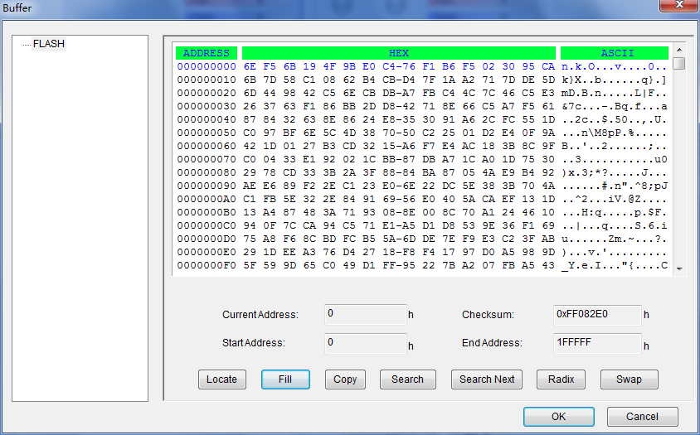
• Locate. Enter the address of the data you wish to display and select OK to

quickly move the cursor to the desired location.

• Fill. To fill the data in the buffer between the Start and End address. For Fuse

buffer, the data must be 0 or 1, and for Data Buffer (HEX/ASCII buffer)

• Copy. Select Copy to open the Copy Buffer dialog box.

o Enter the start address in the Start Address field.

o Enter the end address in the End Address field.

o Select OK to copy the data between the start address and the end

address, beginning with a new address. Otherwise, select Cancel.

• Radix. Select Radix to toggle between the HEX and DEC memory address

display.

• Search. Select Search to search for a specified string. Select Search Next to

begin the next search for the specified string

• Swap. Select Swap to open the Word Swap dialog box, illustrated below.

Select the Word Width option to swap high byte and low byte according to

the specified width in the address range and select OK. Otherwise, select

Cancel.

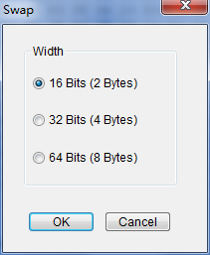
For example, if the data buffer address 0-10(HEX) is:

12 34 56 78 90 AA BB CC - DD EE FF 11 22 33 44 55

Then after swapping the data, it would look like this according to the selected

word width:

o 16 Bits (2 bytes)

34 12 78 56 AA 90 CC BB - EE DD 11 FF 33 22 55 44  

o 32 Bits (4 bytes)

78 56 34 12 CC BB AA 90 - 11 FF EE DD 55 44 33 22

o 64 Bits (8 bytes)

CC BB AA 90 78 56 34 12 - 55 44 33 22 11 FF EE DD

4.3.3.2 Fuse Buffer

When you select Edit from the Buffer menu with the appropriate file type, the

system opens the Fuse Buffer Edit window, illustrated below.

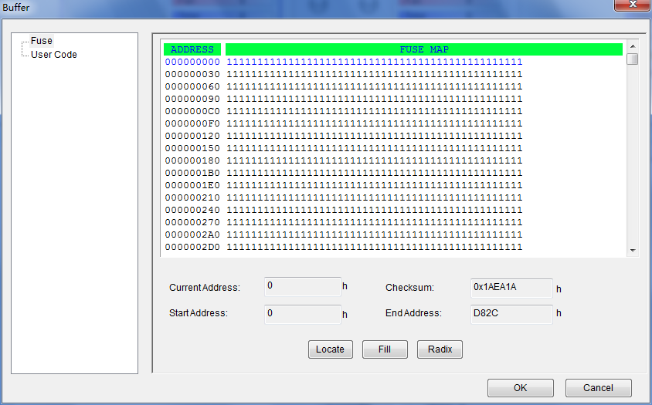
The data for editing is either 0 or 1. Refer to the data manual of the device and the

JEDEC to determine which of the following explanations for the data apply.

• 1 represents an intact fuse and 0 represents a blown fuse, or

• 1 represents a blown fuse and 0 represents an intact fuse

4.3.4 Device Configuration Word

Important: The device configuration word varies from device to device. Refer to the

device data manual for more information about the configuration words. Set the

configuration words according to the requirements of your target system. Otherwise,

you cannot use the device normally even if it is normal when preparing and

verifying the program.

Some single-chip microcomputers allow special working modes, such as the storage

area mapping, the watchdog time, the clock, or the encryption. Set these special

modes through the Device Configuration Word option.

The user files contain the configuration words of some devices. When you load these

files, the system automatically loads the configuration words into the configuration

word buffer. However, you must select the configuration words for some devices

manually.

Select Device Configuration Word from the Device menu to open the ConfigWord

dialog box. The following sample illustration shows the configuration word for

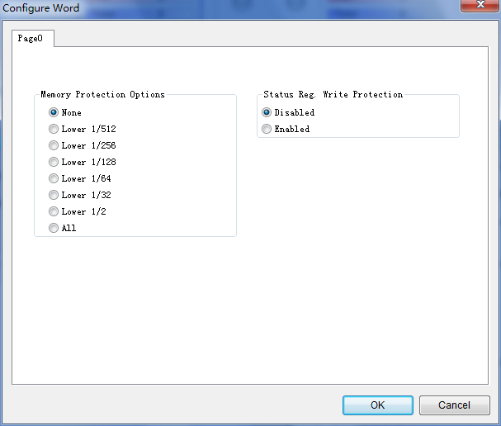
EON,EN25B16(Bottom Boot). It contains the watchdog and three protection modes

Some single-chip microcomputers include many items for the configuration word.

The items may appear on separate tabs or pages. Make sure to set all the items on all

pages before programming a chip. The input of the configuration word can be

divided into several ways:

• The 8-bit (byte) edit box input

• The 16-bit (word) edit box input

• The single choice input (select and deselect, choose one out of two)

• The multiple choice input (choose one out of many)

The configuration words for chip programming are classified into two categories:

• If the configuration word contains some protected items, then you cannot

verify the items after preparing the program. When preparing the program,

the programmer automatically shields the protected items and writes the

other items. Select Security or Protection to write the protected items.

NOTE: If you select None as the Protection option, the system does NOT

carry out an operation when performing Security or Protection.

• In some devices, the configuration words cannot be separated, so the system

does not write the configuration word when preparing the program. To write

the configuration word in these cases, select the corresponding item, such as

Write_Option.

Some FLASH devices also use the configuration word for the protect

operation and to execute and display the segment protection.

4.4 Option Menu
The Option menu includes items to help you program in a specific mode to meet the

targeted system requirements. Before programming a chip, make sure to select the

necessary settings. The General view of the Operation Option screen is illustrated

below. The Operation Option screen includes four tabs:

- General
• Buffer

• Auto.Inc

• Count

Each view is explained in the following sections
4.4.1 General

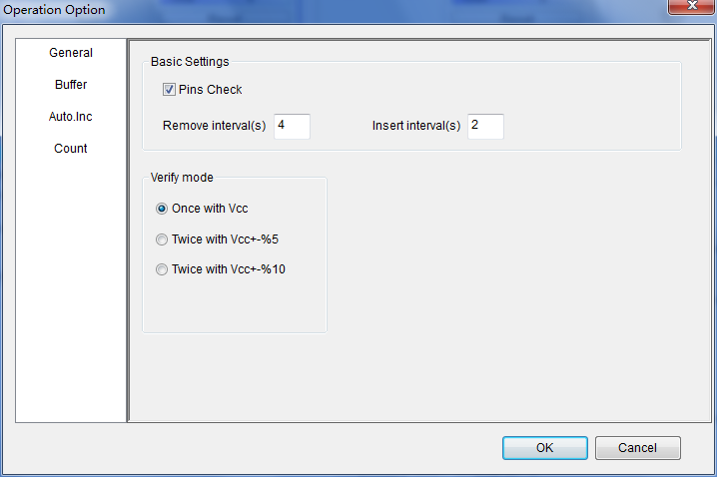

1. For chips with 48 pins or less or for chips with an adaptor that reduces the

chip to 48 pins or less, select Insertion Test to have the programmer check the

pin contact status before programming. The test includes a check for poor

contact, wrong direction, chip insertion, and chip insertion orientation errors.

2. Select ID Check to have the programmer read the Electronic Identifier Code

from the chip to identify the manufacturer, the device type and the

programming algorithm code. If you have already selected the device, the

default for this option is checked.
3. Select Beeper On to turn the beeper on or off. The beeper makes a sound to

indicate the results of operations such as Insertion Test error, ID unmatched,

programming successfully completed or failed.

NOTE: Not all programmers include a beeper.

4. Indicate the mode for verifying the data by selecting one of the Verify Mode

options. These options refer to the voltage of the pin VCC, which may vary

when the programmer verifies the data. The manufacturer provides the

MinVcc and MaxVcc values for verifying the data.

VCC(+/- 5%) or VCC(+/- 10%) is adopted for the verification. If VCC = 5.00V,

select one of the following options:

• VCC = 5.00V and verify the data once

• VCC = 4.75V and VCC = 5.25V, and verify the data twice (+/- 5%)

• VCC=4.50V and VCC=5.50V, and verify the data twice (+/- 10%)

4.4.2 Buffer
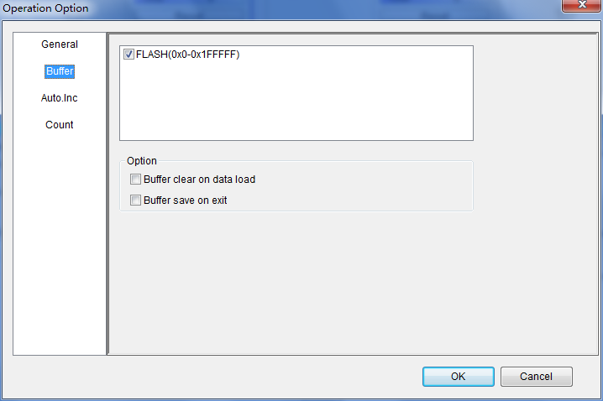
The default programming method is to program the device from the start address to

the end address. However, you may choose to program only a part of the chip, such

as with most E/EPROM (FLASH) devices. (Double click on buffer name and set the range of programming)

4.4.3 Auto Increment (Auto.Inc)

Auto Increment provides two methods of generating the serial numbers: Auto

Increment and User Defined. This function is not available in stand-alone mode.
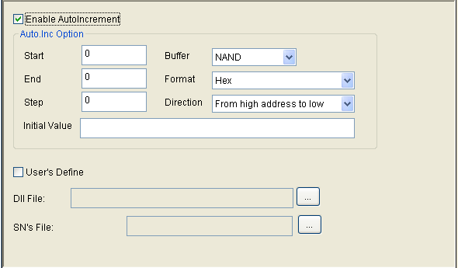

37 of 51

NOTE: The serial number is the content required by some applications that must be

written in a certain area for every chip. This information includes the product

sequence number and the MAC address.

To have the software generate the serial number, select Enable AutoIncrement.

1. Enter the automatic start buffer address in the Start Addr field.

2. Enter the automatic end buffer address in the End Addr field.

3. Enter an increment value less than 10 in the Inc. Step field.

4. The AutoInc Format defines the start value and the overflow value. The

overflow value is the number at which the increment ceases and carries to the

next address, which becomes the new start value.

• Select Binary to set the start value as 0 and the overflow value as 256.

• Select ASCII Decimal to set the start value as 30 (hexadecimal

representation of 0) and the overflow value as 39+1 (the hexadecimal

representation of 9).

• Select ASCII Hex to set the start value as 30 (hexadecimal

representation of 0) and the overflow value as 46+1 (the hexadecimal

representation of a number greater than F, where 9+1=A).

To define the increase of the serial number, select User's Definition. You must be

authorized to use this function. If so, you can change the data as desired in the 4K

byte range.

4.4.4 Count

The Count view of the Operation Option screen is illustrated below. This screen

allows you to change the default setting regarding the statistical work of the

programming status. In the default case, it is only effective for the function

program".

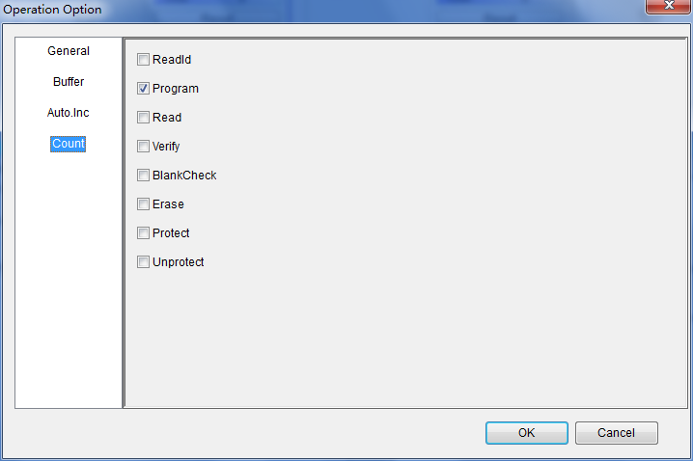

4.5 Edit Auto

The Auto function organizes the different functions of the device into a sequential

group and carries out the functions in order, similar to a batch command.

Edit Auto enables edit functions and operations, in order to automatically execute

the programming procedure according to pre-arranged functions and operations. As can be seen from the figure above, user can select one certain function/operation and

Add, Delete the selected one, or Delete All to cancel all the previous arrangement.

4.6 Tool Bar

The tool bar provides a quick way to execute common functions. The toolbar from

the main SUPERPRO screen is illustrated below. Each tool is labeled with a number

and described below.

1. Load file

2. Save file

3. Load project

4. Save project

5. Edit buffer

6. Calculating the Checksum

7. Select device

8. Device information

9. Device configuration word

10. Edit Auto

11. Option

12. Logic test

13. Production mode

14. Factory mode

15. Global settings

16. Help

4.7 Log History Window

User can create a log file to have the system save Operation Information window

content into a log file when you exit the program. Select Log File from the Option

menu to open the Log File dialog box, illustrated below. The red labels refer to the

numbered explanations below
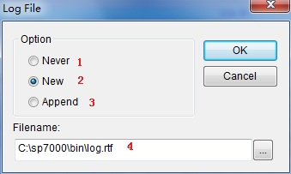
1. Select No to delete the log file. The system will not create a log file on exit.

2. Select New to overwrite the existing log file every time the program starts.

3. Select Append to add the log file information at the end of the existing log

file each time the program starts.

4. Enter, edit or Browse for the full path name of the log file in the Log file's

name: field.

Chapter 5 Frequently Asked Questions (FAQ)

You can monitor the programmer operations through the Operation Information

Window and message window. This chapter helps define common problems related

to programmer actions and errors.

5.1 Dealing with Data Files

This section explains common problems involving the File Type dialog box.

5.1.1 Solve Invalid File Type or File Data Overflow Error

The data for programming is usually stored in the data file. Commonly used formats

are Intel Hex, Motorola and Tektronix. The files of these formats keep data in text

mode, which include data and address information. Because the offset address is not

always zero, you may incur errors when loading the file directly.

For example, the location of data in buffer (as viewed in the Edit Buffer window)

may be incorrect or you may receive an error message when loading the file, such as

Invalid file type, or all file data overflow. Select one of the following options to

solve this problem.

• Confirm the file type and ensure the buffer can load all the files.

• Find the offset address of the file. When loading the file, select the Show

Offset Address (Minimize) After Loading option to display the start address

of the file after the file is loaded.

5.1.2 Separate File Data for Programming

By using the File Mode selection in the File Type dialog box, you can select the data

of a file and write it to several chips of the same type. This allows you to load the file several times according to your needs. There are three methods for separating the

file data:

• Based on byte (8bit), divide the file into two parts by the odd and even

address. Program the two parts into two chips respectively. When loading the

file, select Even as the File Mode to write the data in the addresses 0,2,4,6, etc.

to one chip. Select Odd as the File mode to write the data at the address

1,3,5,7, etc. to the other chip.

• Based on the byte (8-bit), divide the file into four parts by address of the first

byte, the second byte, the third byte and the fourth byte out of every four

bytes. Program the four parts to four chips respectively. When loading the

file, select the 1st byte of 4 as the File Mode to write the data in the addresses

0, 4, 8, 12 (or C if HEX), etc. to one chip. Then select 2nd byte of 4, 3rd byte of

4, and finally 4th byte of 4 to write the remaining data to the other three chips.

• Based on the word (16-bit), divide the file into two parts by address of the

first two bytes and the last two bytes out of every four bytes. Program the

two parts to two chips respectively. When loading the file, select the 1st two

bytes of 4 as the File Mode to write the data in the addresses 0, 1, 5, 6, etc. to

one chip. Then select 2nd two bytes of 4 to write the remaining data to the

other chip.

5.1.3 Program Two or More Files to One Chip

User can load several files into the buffer and write them to the chip. The following

explanation gives an example of programming three files (Sample1, Sample2, and

Sample3) to one chip. The example assumes the following:

• Write the data from the address 200 (Hex) of the file Sample1 to the address 0

of the chip.

- Write the data from the address 0 (Hex) of the file Sample2 to the address 3000 (Hex) of the chip.
• Write the data from the address 4000 (Hex) of the file Sample3 to the address

4000 (Hex) of the chip.

1. Select Edit from the Buffer menu. Make sure that the Buffer clear on data load

option is not checked.

2. Select Load from the File menu to load the Sample1 file.

o In the Buffer Address field, enter 0.

o In the File Address field, enter 200.

3. Select Load from the File menu to load the Sample2 file.

o In the Buffer Address field, enter 3000.

o In the File Address field, enter 0.  

4. Select Load from the File menu to load the Sample3 file.

o In the Buffer Address field, enter 4000.

o In the File Address field, enter 4000.

5. Continue with programming.

If there are no changes in the file requirements or content of the three files (Sample1,

Sample2, and Sample3), you can save the data in buffer to a new file, such as

Sample4, for easy loading and programming next time.

5.1.4 POF Format Files

When programming ALTERA PLD devices the system saves the data in POF format

files. When loading a POF Format file, the system displays a File Type dialog box.

Select one of the following:

1. POF file: The system transforms the data into the Fuse data and checks the

data when you load it to the buffer. You may receive one of the following

errors:
o Unmatched file to this chip: This POF file does not match this chip. The

POF file is related to the device when it is compiled. The error indicates

that this POF file is not for this device. Replace the chip with a matched

one.

o The POF file has errors.

o Load POF file dll error (not found): An auxiliary file has errors. Contact

technical support for assistance.

2. Files of other formats are mainly the JED files. The system saves data in the

buffer in a JED file after reading the chip. You can use this format the next

time you load the file.

5.2 Adapter Selection

The standard programmer configuration supports the DIP devices with 48 or less

pins. If you want your programmer to support a device with more than 48 pins, you

will need an adapter. There are two types of adapters: universal and specific.

• Universal adapters are applicable for all devices of the same encapsulation

and the same number of pins.

• Specific adapters are applicable for certain devices only. For example, if the

number of the pins for economical programmer hardware is not enough,

specific adapters may solve the ‚insufficient number of the pins‛ problem.

This way, the programmer can also support devices with more than 48 pins  

To use devices with pins between 48 and 144, you can choose either the universal

adapter or the specific adapter. To use devices with pins more than 144, you must

use the specific adapter. The Device Information screen displays adapter

information.

5.3 Other Messages

Other error messages are explained below.

• Please edit 'Auto' first: The Auto consequence is blank. Edit Auto and try

again.

• Enter a string to search for: The Hex Edit Search dialog box is blank. Make

sure to enter a specified string or ASCII codes to search for in the Buffer Edit

dialog box.

• The string for search is blank. Input it in Search dialog: Enter a string in the

Buffer Edit dialog box. Then you can use The first time search, Continue to

search, or Search Next functions.

• Search pattern not found!: The system did not find a matched string or

ASCII code.

• User chip is MfgID = 0089, DeviID = 0051: This display on the Operation

Information window indicates that the chip's ID detection function detected a

different ID than specified in the manual.

• ID check error. Ignore: You can ignore the detected ID error and continue the

operation.

• ID check error: The operation stops because of the ID check error. If you have

good knowledge of this chip, you may ignore the ID error and continue the

operation. Exercise caution to avoid damaging the chip.

• Pin check error. Ignore: The system indicates an error during the pin check.

Ignore it and continue.

• Pin check error: An error occurred during the pin check, and the operation

ceased.

• Programmer not found: The programmer is not connected to the PC or it is

connected improperly. Check the connection.

• Programmer not ready: Turn off the programmer power switch and turn it

on again after a few seconds.

• Programmer is running: The programmer hardware is operating. Wait until

the operation is finished.

• File open error: The open file operation failed.

• Out of Memory: The memory overflows.

• Production mode isn't available for this chip: Since the production mode is

dependent on the pin check, the chips without pin check function are not

applicable for production mode.

• Cancel production mode: Cancel the production mode.

• Too long file name: The file name is too long.

• User cancel: The system displays this message after you select Cancel on the

Status bar.

• Can't cancel!: The Cancel operation has failed.

• Not a project file: The file selected is not a project file. After the software is

updated, the software may not be able to identify a previously created file.

You will need to create the file again.

Appendix

XELTEK periodically publishes upgrade software on the XELTEK website. You can

download and upgrade your software from the website. Non‐users may download

the software for evaluation.

Troubleshooting

If the User Manual does not answer your questions, first contact your sales agent or

the distributor. If you still need technical assistance you can call XELTEK between

Mon‐Fri 7:30AM‐12:00PM & 1:00PM ‐ 4:30PM (PST). Make sure you have your

product serial number before calling. Before contacting XELTEK, check the

following to ensure you get the best service.

• Read the User Manual.

• If you receive an error message that is not explained:

o Make sure you can repeat the circumstances that created the error.

o Write down the error message.

• Make sure you have your product serial number.

• Check your computer configuration, including computer brand, free memory

size before starting the software, the video adapter brand, and the operating

system.

• Make sure you are at your computer when you call so the engineer can guide

you through the solution.

Contact Information

XeltekInc.

1296 Kifer Rd. Suite # 605

Sunnyvale, CA 94086

United States

General Consultation

001‐408‐530‐8080

Order/Sales

001‐408‐530‐8080

Email: sales@xeltek.com

Technical Support

001‐408‐530‐8080

Email: techsupport@xeltek.com

Fax: 001‐408‐530‐0096

Website: http://www.xeltek.com

License Agreement

The copyright of the program and the User’s Guide remain the property of XELTEK.

You may:

1. Copy the program for back‐up purposes ONLY in support of its use on a

single computer.

2. Transfer the program and license to another party if the other party agrees to

accept the terms and conditions of this agreement.

You may not:

1. Use this product on a computer system or network that allows the program

to be operated by more than one user at the same time.

2. Modify, copy, or transfer the User's Guide or other documentation or any

copy.

3. Decompile or disassemble any program modules or encrypted devices.

